Contents
Purpose 3
Cyber Security Framework Alignment 4
Scope 4
Consequences 4
Roles and Responsibilities 4
Response Personnel 5
Response Communications 6
Communications 7
Internal 7
External 8
Cyber Security Incident Response Process 9
Preparation 9
Documentation 10
Team 10
Tools 11
Training and Rehearsal 11
Detection and Analysis 11
Aim 12
Incident Documentation 13
Incident Prioritisation 13
Information Impact Assessment 15
Recoverability Effort Assessment 15
Incident Triage 16
Incident Notification 17
Containment, Eradication and Recovery 19
Aim 19
Evidence Gathering and Handling 20
Identification of Attacker(s) 21
Eradication and Recovery 21
Post-Incident Activities 23
Aim 23
Incident Response Plan Testing 24
Definitions 25
Reference Documentation 26
Plan Review 26
Revision History 26
Appendix A. Incident Handling Checklist 27
Appendix B. Incident Response Team 28
Appendix C. Chain of Custody Form 29
{XXXX} Evidence Chain of Custody Tracking Form 29
Appendix D. {XXXX}’s Incident Response Playbooks 30
Appendix E. Incident Register 31
Appendix E. Incident Reporting Form 32
Appendix F. Communication Template – Internal Employees 33
Appendix G. Communication Template – Customers 34
Appendix H. Contacting ACSC 35
Appendix I. Incident Response Contact List 36

Purpose
The purpose of this document is to provide {XXXX} with a set of procedures to respond to a cyber security incident.
Examples of information security incidents may include:
- Data spill or the disclosure of confidential information, such as client voice and data communications, to unauthorised individuals.
- The loss or theft of paper or electronic records, data, or equipment, such as tablets, laptops, or smartphones, on which data is stored.
- Inappropriate access controls allowing unauthorised access to information.
- The suspected breach of {XXXX}’s IT, communications and/or acceptable usage policies.
- Attempts to gain unauthorised access to {XXXX} or {XXXX} managed client computer systems (e.g., hacking).
- The alteration or deletion of records without explicit authorisation from the data “owner”.
- A virus, malware, denial of service and/or other form of security attack on {XXXX}’s IT systems and/or networks.
- The breaches of physical security (e.g., forcing of doors and/or windows into secure rooms and/or filing cabinets containing confidential information left unlocked in accessible areas).
- IT equipment left unattended whilst logged in to a user account, without locking the screen, or suspending the session to stop others accessing information.
- The covert and/or unauthorised recording of conversations, meetings and/or presentations.
This plan aims to:
- Implement a formal, focused, and coordinated incident response approach.
- Provide clear direction to all employees, contractors, service providers, and external parties, defining the phases in handling and reacting to actual or probable security incidents.
- Establish the roles and responsibilities for those responsible for incident handling.
- Establish a list of contacts and define escalation procedures in the event of an incident.
- Detail flow charts for incidents and/or event response.
- Develop a plan for continuous improvement in incident response.
Further, by having a systematic and well-defined incident response plan in place, {XXXX} is better positioned to:
- Understand the extent and source of an incident.
- Protect sensitive data contained on systems.
- Protect the systems and networks, and ensure their ability to continue operating as intended.
- Recover systems.
- Prevent recurrence.
- Support legal investigations.
- Report internally and to appropriate external authorities.

Cyber Security Framework Alignment
This document aligns with the ISO 27001 and ISO 2700:2022 frameworks. For more details, see the [XXXX] cyber security policy and policy document: [XXXXXXXX]

Scope
This plan applies to all {XXXX} IT systems, equipment, and information assets and access to information owned or in the custody of {XXXX}.
The requirements and expectations outlined in this procedure apply equally to all personnel defined as:
- All {XXXX} workers (including directors, employees, subcontractors, volunteers, and visitors).
- All suppliers providing services to {XXXX}.

Consequences
Without a well-considered IRP, {XXXX} may be inadequately prepared to address Information Security incidents, potentially resulting in poor decision making, haphazard and/or ineffective action, or failure to comply with reporting and notification requirements and expectations. This could further lead to but not limited to:
- Extensive loss of or damage to data.
- Increased costs, loss of productivity, and loss of business.
- Spread of the incident to other systems.
- Reputational damage to the organisation.
- Legal action.

Roles and Responsibilities
Table 1: Roles and Responsibilities
Role | Responsibilities
Chief Executive Officer (CEO) | Oversee legal matters in relation to incident management.
Executive Leadership Team (ELT) | Provide authorisation to the ISO Governance Committee (ISOGC) to approve policies, standards, and procedures.
Information Security Council (ISC) | Reviews and endorses this plan.
CIO | Responsible for establishing adequate controls to comply with this plan.  Reviews and endorses this plan.
Managers and Supervisors | Responsible for advising users of their obligations under this plan, monitoring and, where necessary, enforcing the plan.
Information Owner | Approves access for either individuals or groups.
Employees, contractors, and third parties | Ethical and efficient use of IT assets as prescribed in this general plan and other related policies.
All users | Reporting security incidents and any identified weaknesses.

Response Personnel
{XXXX} will establish an Incident Response Team (IRT) to provide prompt and orderly responses to Information Security incidents, as outlined in ‘Appendix B. Incident Response Team’. The IRT is expected to promptly respond to any unexpected incident and report its findings to executive management and the appropriate authorities. Members of the IRT, in addition to the IRT itself, must subscribe to security industry and/or relevant vendor alert services, keeping abreast of threats, vulnerabilities, and alerts.

Response Communications
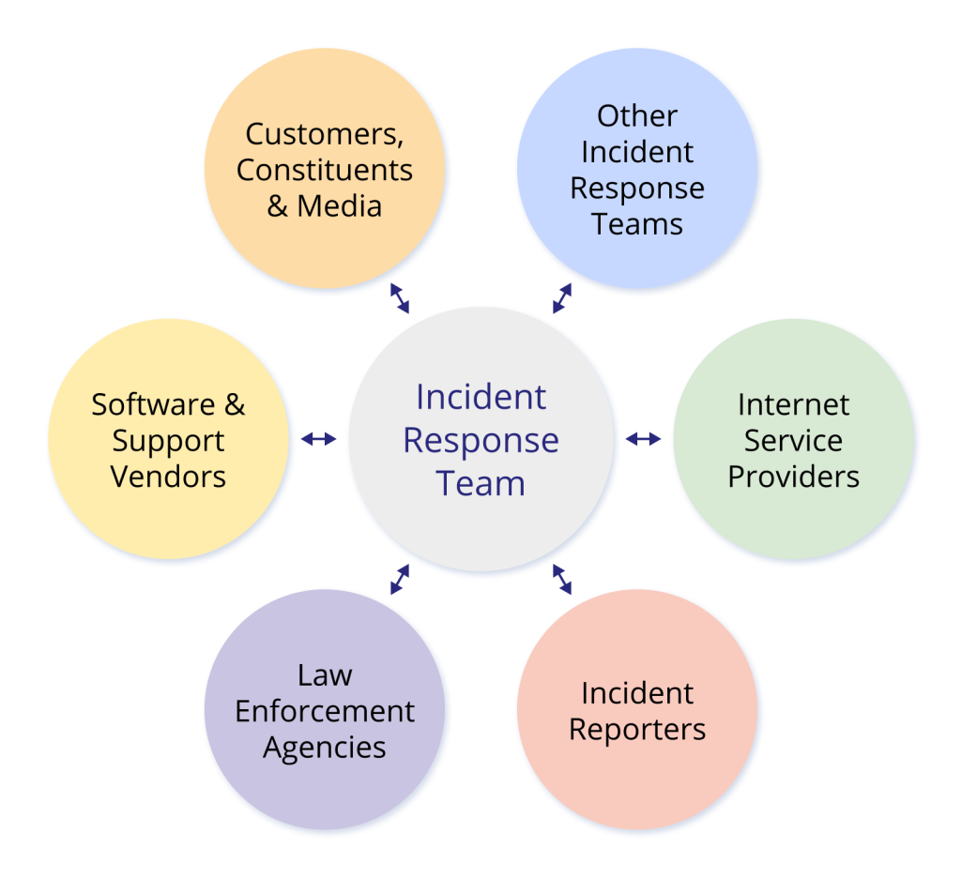
Figure 1: Incident Response Team Communication Recipients
Upon the discovery of a potential cyber security incident, the following internal contacts must be kept up to date with the investigation and the life cycle of the investigation. This should be done using the Incident Reporting form in ‘Appendix E. Incident Reporting Form’. Internal communications parties are as follows:
- General Manager – Transformation
- General Manager – Information Technology
- GM People, Learning and Culture
- Legal Counsel
- GM Risk, Compliance and Safety
- Senior Systems Engineer

Communications

Internal
Table 2: Internal Communications
Who to Inform | What | Responsible for Notification | When
CEO | Inform/Escalate | General Manager – Information Technology | As soon as a moderate or higher impact cyber security incident is identified.
Legal Counsel | Communication and legal support | CEO | Provide comprehensive understanding of notification obligations, potential liabilities, and the correct process for communicating with affected parties or regulators.
Senior Systems Engineer Technology | Inform  Request Assistance | General Manager – Information Technology | IT Support should be contacted to inform them of a disruption or request assistance to manage user access within the {XXXX} IT environment.
GM People, Learning and Culture | Inform  Request Assistance | General Manager – Information Technology | Human Resources and the CEO should be contacted immediately to inform of any incidents which may require organisational or external communications.  Follow up communications are required to either confirm the incident and arrange appropriate communications, or confirm no further action is required.
GM Risk, Compliance and Safety | Inform  Request Assistance | General Manager – Information Technology | The CRO should be contacted immediately to inform of any incidents impacting personally identifiable information and requiring a data breach notification, or otherwise may require legal involvement, such as criminal activity.  Follow up communications are required to either confirm the incident and arrange appropriate communications, or confirm no further action is required.
Out-of-hours support centre | Inform  Request Assistance | General Manager – Information Technology | The CIO should be contacted if an incident is detected outside of normal business hours and IT support is required.

During the investigation of actual or potential incidents, {XXXX} may need to communicate with external parties such as:
- Internet/Telco service providers  - Owners of the address space from which an attack is originating  - Law enforcement agencies  - Media organisations  - Software and/or application vendors  - Third-party vendors | - Australian Cyber Security Centre (ACSC), see ‘Appendix H. Contacting ACSC’  - Customers and/or other affected parties  - AUSCERT  - Privacy Commissioner  - Law Enforcement

External
Table 3: External Communications
Who to Inform | What | Responsible for Notification | When
(business unit, for example)  Department of Education, Skills, and Employment | Inform | General Manager – Information Technology | Must notify within 72 hours after becoming aware of an incident that has materially affected or has the potential to materially affect or has been reported to their regulators.
ISP gateway | Inform  Request Assistance | General Manager – Information Technology | If an incident requires assistance from the ISP to manage an external denial-of-service-style attack targeting the {XXXX} IT environment.
Website | Inform  Request Assistance | General Manager – Information Technology | If a denial-of-service-style attack targets the {XXXX} website.
Office of the Australian Information Commissioner | Inform | GM Risk, Compliance and Safety | If a notifiable data breach occurs.
ACSC | Inform | General Manager – Information Technology | All potential cyber breaches.
If these communication mediums are rendered unavailable, or it is suspected that an attacker has access to internal communications mediums during a cyber incident, the mobile network shall be used as an out-of-band backup.

Cyber Security Incident Response Process
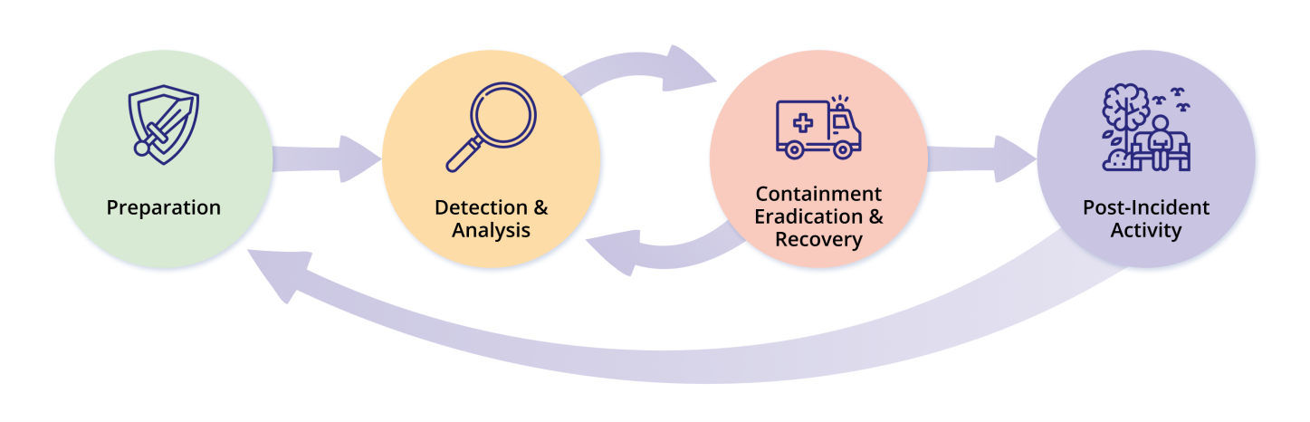
Incident response activities are grouped as per these phases:
Figure 2: Incident Response Life Cycle
An Incident Response Checklist aligned with this process is reflected in ‘Appendix A. Incident Handling Checklist’.
The following sub-sections describe, in detail, the major phases of the incident response life cycle. A high-level process flow for incident response activities is provided in ‘Appendix D. {XXXX}’s Incident Response Playbooks’, which outlines steps to be taken at each stage of the incident response life cycle for certain defined incident scenarios.

Preparation
To be in readiness with a set of established policies, procedures, and mechanisms for responding to incidents, and to proactively prevent incidents from occurring. This includes exercising this plan in advance so that key resources are familiar with the processes, protocols, and requirements, and that they have been proven through testing.
{XXXX} shall be generally prepared to handle incidents that use commonly known attack vectors. Further, {XXXX} shall be familiar with attack precursors and/or indicators. A precursor is a sign that an incident may occur in the future.
Common attack vectors in the current cyber threat landscape include:
- Insider Threats: Employees or contractors misusing their access to harm the organisation or steal data.
- Social Engineering: Manipulating individuals into divulging confidential information or performing actions that compromise security.
- External and/or removable media: such as an infected USB drives.
- Attrition: Attack that employs brute-force methods to compromise, degrade, or destroy systems, networks, and/or services.
- Website and/or web-based applications.
- Email via attachments or malicious links.
- Impersonation, involving the replacement of something benign with something malicious.
- Improper usage, resulting from a breach of acceptable use of {XXXX}’s resources by an authorised user.
- Loss of theft and/or equipment, such as a laptop, smartphone, and/or authentication token.
- Other attacks that do not fit into any of the above categories.
The key components of preparedness are described and detailed in the following sections.

Documentation
Appropriate documentation, such as the IRP, incident handling contact list, incident workflow, incident forms, checklists etc., must be developed and maintained. A sample Incident Reporting Form and Incident Register are included within ‘Appendix E. Incident Reporting Form’ and ‘Appendix D. Incident Register’ respectively. All of the IRP documentation components must be reviewed at least annually.

Team
Each member’s incident response duties should be clarified based on their primary discipline (e.g., HR for privacy breaches, Legal for compliance/reporting, PR for communications).
IBRS Note: Consider adding a RACI matrix.
The IRT at {XXXX} consists of personnel from different disciplines such as technical team, HR, Legal, public relations, etc. These personnel do not have a permanent incident handling role, i.e., their full-time roles are not incident response; but they shall be educated to undertake incident response procedures when the necessity arises. The IRT members are outlined in ‘Appendix B. Incident Response Team’.

Tools
The IRT should aim to have adequate tools and methods for addressing incidents. Some of the tools should be forensic software, an anti-malware toolkit, write-block devices, a bootable USB drive, incident response forms, hard copies of contact lists and checklists, etc. If not possible, {XXXX} may choose to involve a third party to assist in this aspect of incident response.

Training and Rehearsal
Regular training and incident handling drills shall be provided to ensure that the IRT is capable of responding to incidents effectively. A security awareness program within the organisation must be established to ensure that employees can identify and notify the appropriate party when security incidents occur. This will assist in the early detection of an incident and help to reduce the potential impact.

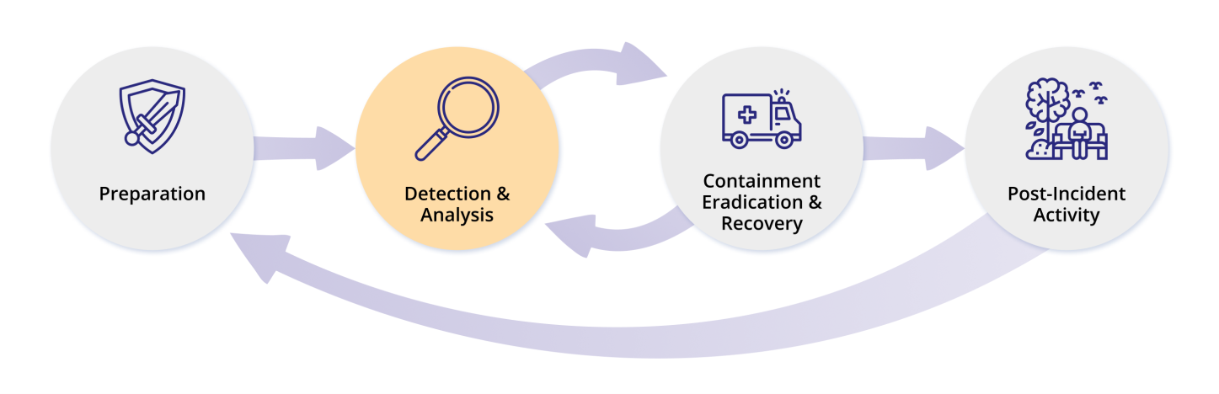
Detection and Analysis
Figure 3: Incident Response Life Cycle – Detection and Analysis Phase

Aim
To be alerted to the fact that an incident has occurred or is occurring, to understand its nature and determine what the affected systems are, i.e., the extent.
Detection/alerting can originate from, but is not limited to:
Alerts:
- Intrusion Detection and/or Prevention Systems (IDS/IPS).
- Security Information and Event Management (SIEM) systems.
- Anti-viral, anti-spam, and/or anti-malware applications.
- File integrity checking software.
- Third-party monitoring services.
Logs:
- Operating system, service and/or application logs.
- Network device logs.
- Network flows.
Publicly Available Information:
- Information on new vulnerabilities and exploits (i.e., threat intelligence services).
People:
- People from within the organisation.
- People from other organisations.
At a minimum, {XXXX} shall monitor all systems for suspicious activity, looking specifically, but not limited to:
- Usage of a vulnerability scanner against a {XXXX} website or infrastructure device (attack reconnaissance).
- Unusual characters or changes within filenames.
- Recordings of configuration changes via audit logs.
- Multiple failed login attempts, irrespective of whether the system is familiar or not.
- Many failed and/or returned emails with suspicious content.
- Unusual deviations from typical network traffic flows.
- Impersonation/social engineering.
- Improper usage/violation of acceptable use, loss, or theft of equipment.

Incident Documentation
Documentation is a key component of any incident response and shall be strictly performed in accordance with {XXXX}’s internal policies for documentation. Documentation formulation shall immediately proceed on advice that an incident has or may be occurring. Documentation of system events, conversations, and observed changes in files can lead to a more efficient, systematic, and error-free resolution of problems. Every step and/or document in relation to the incident must be:
- Documented.
- Time-stamped.
- Dated.
- Signed by the incident handler.
{XXXX}’s IRT shall maintain all records in relation to the status of incidents, along with other pertinent information. Such records shall contain, but not be limited to:
- The status of the incident, whether it be new, in progress, forwarded for investigation, resolved, etc.
- An incident summary.
- Documentation of the indicators of compromise related to the incident.
- Documentation on other related incidents.
- Documentation of actions taken by all incident handlers in relation to the incident.
- Chain of custody documentation for all evidence, inclusive of a list of all evidence gathered during the investigation.
- Documentation of impact assessments related to the incident.
- Contact information for all involved parties, inclusive of, but not limited to, system owners and/or administrators.
- Comments from incident handlers.
- Next steps to be taken include rebuilding hosts and/or upgrading applications.
{XXXX}’s IRT shall ensure that incident data is safeguarded with access restricted to those with need-to-know rights only and access must be logged in a register.

Incident Prioritisation
A critical decision point within the incident handling process is the prioritisation of incidents. Incidents should not be handled on a first-come, first-served basis because of resource limitations, but rather prioritised based on relevant factors, which may include, but shall not be limited to:
- The functional impact of the incident.
- The information impact of the incident.
- The recoverability from the incident.
{XXXX} shall quantify the effect of an incident as it is aware of its situational surroundings. The following table provides impact categories that {XXXX} shall use for the rating of incidents:
Table 5: Impact and Priority Level Indicators
Combining the functional impact to {XXXX}’s systems and the impact to {XXXX}’s information shall determine the business impact of an incident. The recoverability from an incident shall determine the possible response that the IRT may choose to take whilst handling an incident:
Category | Definition
Priority Level 3 (Default) | An event that affects one person in a minor way and can be adequately managed by normal management and/or operational processes and has clearly defined circumstances, life, property, or the environment is not threatened, and it should have insignificant to low impact on {XXXX}’s ability to operate, its reputation, and profitability.  Examples include but are not limited to: a single user receives a phishing email but does not click any links or provide information. A user is locked out of their account due to repeated failed logins (no evidence of compromise). An employee inadvertently sends a non-sensitive email to the wrong internal recipient. Detection of a low-severity malware on a workstation, quickly quarantined with no further spread.
Priority Level 2  (P2) | An event that can be adequately managed by normal management and/or operational processes and has clearly defined circumstances, life, property, or the environment is not threatened, and it should have insignificant to low impact on the organisation’s ability to operate, its reputation, and profitability.  Examples include but are not limited to: A targeted phishing campaign where a few employees received and reported suspicious emails, but no credentials were compromised. A minor Distributed Denial of Service (DDoS) attack causing slow access to a non-essential company website, resolved within SLA. Malware detected on a shared drive, but contained before any data exfiltration or major spread occurs.
Priority Level 1  (P1) | An event in which existing processes and/or management lose positive control and one that is not clearly defined. It may threaten life, property, or the environment and if not responded to in an appropriate manner, may have a HIGH adverse impact on the organisation’s ability to operate, its reputation, and profitability.  Examples include but are not limited to: A ransomware attack encrypts critical business systems, halting core operations across multiple departments. A significant data breach involving sensitive customer or employee information, requiring regulatory reporting and customer notification. Compromise of privileged or administrative accounts affecting multiple systems or business units. A widespread malware outbreak that disrupts major business functions or critical infrastructure services. A successful cyber attack resulting in prolonged outage of essential systems (e.g., payroll, finance, healthcare delivery systems).

Information Impact Assessment
Incidents may affect the confidentiality, integrity, and availability of {XXXX}’s information. Incident handlers should consider how any unauthorised event will impact not only {XXXX}’s overall mission but also business partners.
Table 6: Information Impact Assessment
Category | Definition
Insignificant | No information was exfiltrated, changed, deleted, or otherwise compromised.
Minor (Privacy Breach) | Confidential information has been accessed or exfiltrated.
Moderate (Proprietary Breach) | Proprietary information has been accessed or exfiltrated.
Major (Integrity Loss) | Confidential or restricted information was changed or deleted.
Extreme | Confidential or restricted information has been stolen and made public.

Recoverability Effort Assessment
The size and type of resources affected by the incident determine the amount of time and resources required to recover from it. In some instances, recovery is not possible. In these cases, effort is to be directed at minimising the resulting impact and ensuring that a similar incident cannot occur in the future.
The recoverability from the incident determines the possible responses that {XXXX} will take when handling an incident.
For example, while an incident with high impact and low recoverability can and should be addressed immediately, an incident with high recoverability will require a more strategic, longer-term response plan.
Incident handlers should consider the effort necessary to recover from an incident and weigh that against the value the recovery effort will create.
Table 7: Recoverability Effort Assessment
Category | Definition
Regular | Time to recover is predictable with existing resources.
Supplemented | Time to recover is predictable with additional resources.
Extended | Time to recover is unpredictable; additional resource and outside assistance is required.
Non-recoverable | Recovery from the incident is not possible, for example, when sensitive data is exfiltrated and posted publicly.

Incident Triage
The following table provides a list of common cyber incident types with their corresponding initial technical response activities and related playbooks.
Incident responders are to complete an Incident Report for every event investigated:
Table 8: Incident Triage
Type / Description | Initial Technical Response | Playbook
Unauthorised Access:  Gaining unauthorised access to a legitimate account or gaining unauthorised escalated privileges. | Immediately disable the affected account.  Capture all logs relevant to the compromised account. | Unauthorised access
Denial of Service (DoS/DDoS):  Overwhelming an IT network with traffic that it cannot process causing the network to fail. | Request gateway service provider to identify DoS/DDoS nature and attack vector.  Liaise with gateway service provider and network team to apply filters at network edge and/or increase capacity. | Denial of Service
Data Access/Data Breach:  Unauthorised access or disclosure of proprietary, sensitive, or personally identifiable information. | Alert GM, IT.  Investigate the cause and impact of the data loss/spill with a focus on containment. | Data Breach
Malware Infection:  A virus, worm, trojan, or other code-based malicious entity that successfully infects a host. | Remove/isolate the infected device(s) from the network to limit the spread of malware.  Capture all available logs relevant to the device.  Continue to isolate the device while containment activities are confirmed, and eradication/recovery efforts are determined. | Malware on a desktop  Malware on a server  Ransomware
Social Engineering:  Manipulation of individuals to perform actions or release sensitive information for the purpose of information gathering, fraud, and/or system access. | Review logs of affected users (web and email) to determine whether malicious links were accessed.  Consult users to confirm what actions were taken and whether any personal/sensitive information was exposed. | Social Engineering
Advanced Threat Actor:  Identification of an ongoing or persistent intrusion into the environment. | Report to Australian Signals Directorate (ASD) Report a Cyber Crime at cyber.gov.au/acsc/report.  Note: Do not try to perform response activities yourself (e.g. do not unplug machines, do not run malware scans manually, do not ping back remote IP address). | Advanced Threat Actor

Incident Notification
Once {XXXX}’s Incident Response Team have analysed and prioritised an incident, the team shall notify appropriate individuals to enact their response procedures and activate their roles within the incident response process.
{XXXX} should identify and document the list of personnel and organisations to notify during an incident. Contact details of all identified stakeholders must be maintained within the ‘Appendix I. Incident Response Contact List’.
Notwithstanding the above personnel and organisations, {XXXX}’s IRT should provide status updates to certain parties, and in limited cases, to the entire organisation. {XXXX}’s Incident Response and/or Handling Teams shall plan and prepare several communication methods, including out-of-band methods such as in-person or paper-based, and select the most appropriate method for the respective incident. Communication methods may include, but are not limited to:
- Email.
- Web application.
- Telephone calls.
- In-person.
- Voice mailbox greetings, by configuring a dedicated mailbox for incident updates, updating the greeting message to reflect the status of the incident.
- Paper-based, by posting notices on bulletin boards and doors or handing out notices at all entrance/exit points.
The following table summarises, at a high level, {XXXX} incident response communication obligations related to priority 1 and/or major/extreme information impact assessments.

Table 9: Incident Communications
Who | What | Notifier | When
Affected personnel or organisations | Inform | CEO  If unavailable, another member of the ISC. | ASAP, after a security incident pertaining to the respective personnel/organisations has been:  Identified and confirmed.  Resolved or remediated.
Board, CEO | Inform | General Manager – Information Technology.  If unavailable, another member of the ISC. | ASAP, when legal action may be imminent pertaining to an information security incident.
General Manager – Information Technology | Inform | Incident lead | ASAP, after becoming aware of a security incident that has:  Affected, or had the potential to affect, financially or non-financially, {XXXX} or the interests of customers.  Has been notified to other regulators.
A template to communicate with Internal Employees and customers regarding incidents is provided within ‘Appendix F. Communication Template – Internal Employees’, and ‘Appendix G. Communication Template – Customers’, respectively.

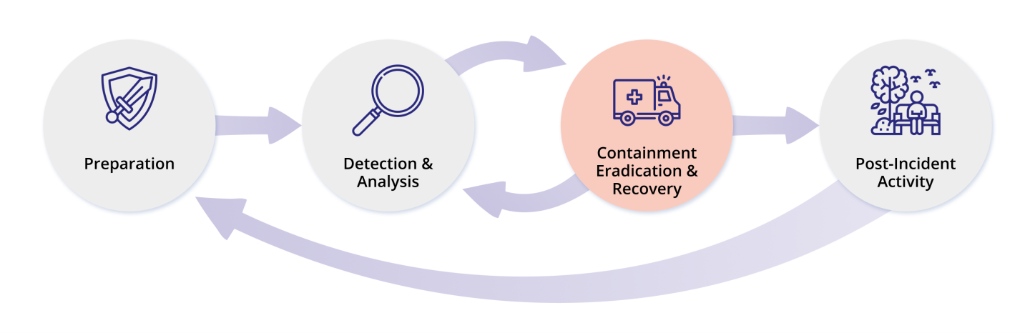
Containment, Eradication and Recovery
Figure 4: Incident Response Life Cycle – Containment, Eradication and Recovery Phase

Aim
To stop or limit the extent of the incident, to determine ongoing operational continuity, to ensure removal of any unauthorised actors and/or binaries from the system(s) completely and to return all of the affected systems and networks to operational status.
An essential part of containment is decision-making, which may include:
- Shutting down a system and/or device.
- Disconnecting a system and/or device from the network.
- Restoring a system from an earlier snapshot.
- Disabling certain services and/or functions that may disrupt operations.
- Restrict access to data if and where possible.
{XXXX} is committed to develop containment strategies, varying such strategies based on the type of incident and acceptable level of risk. All strategies should contain specific criterion, including, but not limited to:
- The potential damage to and/or theft of resources.
- The need for evidence preservation.
- The requirement for service availability, inclusive of network connectivity, and/or services provided to external parties.
- The time and resources needed to implement such strategies.
- The effectiveness of the strategy, whether it be partial containment or full containment.
- The duration of the solution, where it be an emergency workaround to be removed in a few hours, or a temporary workaround to be removed in a few weeks, or a permanent solution.

Evidence Gathering and Handling
Although the primary reason for gathering evidence during an incident is to resolve the incident, it may also be needed for legal proceedings. In such cases, it is important to clearly document how all evidence, including compromised systems, has been preserved. Evidence must be collected in accordance with procedures that comply with all applicable laws. Evidence may need to be copied to external media for archiving, with appropriate file integrity checks to confirm the integrity of the evidence. The retention period of evidence pertaining to incidents is a minimum of seven (7) years after the conclusion of any investigation or legal proceedings in which evidence was submitted or used.
Incident evidence will be obtained at the earliest opportunity to determine the scope of the incident and identify whether the incident has, will, or could impact other areas of {XXXX}.
During the early stages of incident response, it may not be immediately apparent that a security incident has occurred. A danger exists that necessary evidence may be corrupted or destroyed, intentionally or accidentally, before the seriousness of the incident is realised.
Information must be obtained and assessed as early as possible to determine whether an incident has occurred, as this may influence the incident response process, the evidence to be collected, and the method of evidence collection.
Audit trails and similar evidence shall be collected and secured for use in:
- Internal problem analysis.
- Relation to potential civil or criminal legal proceedings.
- Potential compensation negotiations with other parties.
Whenever evidence is transferred from one person to another, a chain of custody form shall be used to detail the transfer and include the signatures of each party involved. ‘Appendix C. Chain of Custody Form’ contains a sample usable chain of custody form.

Identification of Attacker(s)
During incident handling, {XXXX} system owners and/or other {XXXX} personnel may want or need to identify the attacking host or hosts. Identifying an attacking host can be a time-consuming and complex process that can prevent a team from achieving its primary goal of minimising the business impact.
Commonly performed activities for attacker identification include, but are not limited to:
- Validation of the attacker’s Internet Protocol (IP) address.
- Research of an attacker’s IP through search engines and/or open-source threat intelligence and/or exchange systems.
- Monitoring possible attacker communication channels, such as Internet Relay Chat (IRC) channels.

Eradication and Recovery
Post-incident containment, eradication may be necessary to eliminate components of the incident, such as deleting malware and/or disabling breached user accounts. This should also include identifying and mitigating all vulnerabilities that were exploited. During eradication, it is important to identify all affected hosts within {XXXX} so that they can be remediated. Depending on the incident at hand, eradication is either not necessary or is performed during the recovery process.
During the recovery phases, {XXXX} system owners and administrators shall:
- Restore systems to normal operation.
- Confirm that the systems are functioning normally.
- Remediate vulnerabilities to prevent similar incidents.
Recovery actions may involve:
- Resetting user account profiles.
- Restoring systems from clean backups/snapshots.
- Utilise antivirus software to remove the infection from infected systems and media where possible.
- Rebuilding systems from scratch.
- Replacing compromised files with clean versions.
- Installing patches.
- Increase system logging and/or network monitoring.
- Keying material is changed or rotated when compromised or suspected of being compromised.
- Changing passwords where they are directly compromised or suspected of compromise.
- Tightening network perimeter security (e.g., firewall rulesets, boundary router access control lists).
{XXXX} will perform eradication and recovery in a phased approach, prioritising remediation steps. For large-scale incidents, recovery may take months. Due to this, the intent of the early eradication and recovery phases should be to increase overall security through relatively quick (days to weeks) high-value changes, thereby preventing future incidents. Subsequent phases should then focus on longer-term changes (e.g., infrastructure modifications) and ongoing efforts to maintain {XXXX} as securely as possible.

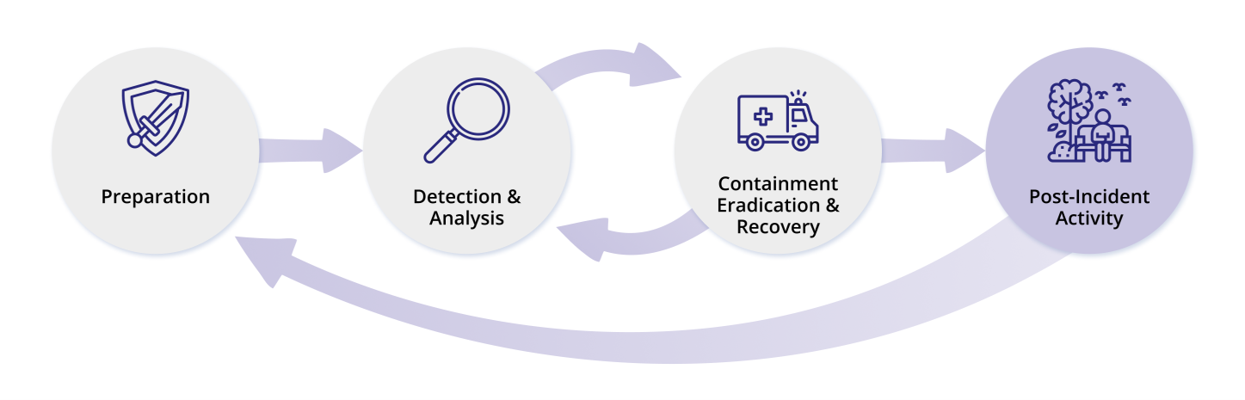
Post-Incident Activities
Figure 5: Incident Response Life Cycle – Post Incident Activity Phase

Aim
To eliminate or mitigate the factor(s) and rectify the security controls that allowed the incident to occur, to identify and build-in lessons learned to {XXXX} practices, and to ensure all key stakeholders are informed.
A key part of incident response is learning and improving. {XXXX}’s IRT should evolve to reflect new threats, improved technology, and lessons learned. {XXXX} shall hold a lessons learned meeting with all involved parties after a major incident, and optionally periodically after lesser incidents as resources permit. Questions to be answered in these meetings, which should be held no longer than a few days after an incident, should include, but may not be limited to:
- Root cause analysis to identify factors that resulted in the incident.
- Exactly what happened, and at what times.
- Ascertain whether similar incidents have occurred before.
- How well did staff and management perform in dealing with the incident?
- Were documented procedures followed?
- Assess whether the incident was correctly categorised and triaged.
- Were documented procedures adequate?
- What information was needed sooner?
- Were any steps or actions taken that might have inhibited the recovery?
- If a similar incident occurs, what will staff, and management do differently the next time?
- How could information sharing with other organisations have been improved?
- What corrective actions can prevent similar incidents in the future?
- What precursors or indicators should be watched for in the future to detect similar incidents?
- What additional tools or resources are needed to detect, analyse, and mitigate future incidents?
- Review the containment and recovery actions performed.
- Document any corrective actions that may be required.
Updating incident response policies and procedures may be undertaken as part of the lessons learned process. {XXXX}’s IRT should review all related documentation and procedures for handling incidents at regular designated intervals to keep them current. An incident report or summary should also be circulated to key stakeholders, which documents the outcomes of the aforementioned elements.

Incident Response Plan Testing
Testing of this incident response plan will be performed according to the schedule defined in the ISMS Security Calendar. These tests range from basic social engineering exercises through to scenario and advanced red-teaming exercises.

Definitions
The following terms have similar meanings across various aspects of incident management. For clarity, the following table provides specific definitions related to cyber security, aligned with the ISO/IEC 27035:2011 Standard.
Table 12: Cyber Incident Management Definitions
Term | Definition
Event | A cyber security event (event) is an identified occurrence of a system, service or network state indicating a possible breach of information security policy or failure of safeguards, or an otherwise previously unknown situation that may be relevant to cyber security.
Alert | A cyber security alert (alert) is a notified exception to the normal operation of digital infrastructure, systems or services. Not all alerts become incidents.
Incident | A cyber security incident (incident) is a single or series of unauthorised cyber security events that occur that have a significant probability of compromising the normal operation of {XXXX}’s digital infrastructure, systems, or services in such a way that the organisation is negatively impacted.  The Cyber Security Checklist must be completed for every incident and filed with the incident report.
Compromise | A cyber security incident where the Confidentiality, Integrity and Availability (CIA) of a system or information was successfully impacted.
Data Breach | A cyber security incident where personal information held or managed by {XXXX} is lost or subjected to unauthorised access, modification, disclosure, or other misuse or interference.
CIA | Refers to the Confidentiality, Integrity, and Availability of information assets.
Confidential | Information that requires additional handling care due to its sensitivity or moderate business impact if compromised or lost.

Reference Documentation
This plan will be read in conjunction with:
- {XXXX} Business Continuity Plan (BCP).
- {XXXX} Incident Response Playbook – Data Breach.
- {XXXX} Incident Response Playbook – Denial of Service.
- {XXXX} Incident Response Playbook – Malware.
- {XXXX} Incident Response Playbook – Social Engineering.
- {XXXX} Incident Response Playbook – Unauthorised Access.
- National Institute of Standards and Technology (NIST) Computer Security Incident Handling Guide (‘NIST SP 800-61’).
- {XXXX}’s suite of information security policies and procedures.
- ISO/IEC 27001:2013 Information Security Standard.

Plan Review
This plan shall be subject to annual review or if significant changes occur to ensure its continuing suitability, adequacy, and effectiveness. Reviews shall incorporate:
- Assessment of opportunities for improvement of {XXXX}’s approach to information security.
- Consideration of changes to the organisational environment, business circumstances, legal conditions, or the technical environment.
This plan may only be amended by resolution of the Information Security Council (ISC).

Revision History
Table 13: Revision History
Ver | Effective Date | Changes | Reviewed by | Approved by
0.1
1.0
* Still requiring some names to be added to table

Appendix A. Incident Handling Checklist
The following checklist outlines the key steps to be taken in incident handling. Please note that the actual steps taken may vary depending on the type and nature of the incident.
Incident Handling Checklist
Step | Action |  | Completed
Detection and Analysis Phase
1 | Determine whether an incident has occurred.
1 | 1.1 | Communicate to the GM, IT that an incident is being investigated.
1 | 1.2 | Analyse the precursors and indicators.
1 | 1.3 | Look for correlating information.
1 | 1.4 | Perform research (e.g., search engines, knowledge bases, threat intelligence systems).
1 | 1.5 | As soon as the incident handlers believe an incident has occurred, they begin documenting the investigation and gathering evidence.
2 | Prioritise handling of the incident based on the relevant factors (functional impact, information impact, recoverability effort, etc.).
3 | Report the incident to the appropriate internal personnel (GM, IT or delegate) and external organisations.
Containment, Eradication and Recovery Phase
4 | Acquire, preserve, secure, and document evidence.
5 | Contain the incident.
6 | Eradicate the incident.
6 | 6.1 | Identify and mitigate all vulnerabilities that were exploited.
6 | 6.2 | Remove malware, inappropriate materials, and other components.
6 | 6.3 | If more affected hosts are discovered (e.g., new malware infections), repeat Detection and Analysis steps 1.1 and 1.2 to identify all other affected hosts, then contain (5) and eradicate (6) the incident for each of them.
7 | Recovery from the incident.
7 | 7.1 | Return affected systems to an operationally ready state.
7 | 7.2 | Confirm that the affected systems are functioning normally.
7 | 7.3 | If necessary, implement additional monitoring to look for future related activity.
Post-Incident Activity Phase
8 | Create a follow-up report.
9 | Hold a lessons learned meeting.
10 | Plan remediation steps and assign relevant actions.

Appendix B. Incident Response Team
General Manager ICT
Chief Transformation Officer
ICT Team Leads (where appropriate)

Appendix C. Chain of Custody Form

{XXXX} Evidence Chain of Custody Tracking Form
Every Evidence Item Must Have a Separate Chain of Custody Form
Incident/Contact Details
Incident Number: |  | Victim:
Supervising Officer: |  | Suspect:
Collection Method: |  | Offense:
Date/Time Seized:
Location of Seisure:

Description of Evidence
Item # | Quantity | Description of Item (Model, Serial #, Condition, Marks, Scratches)

Chain of Custody
Item # | Date/Time | Released by  (Signature & ID#) | Received by  (Signature & ID#) | Comments/Location

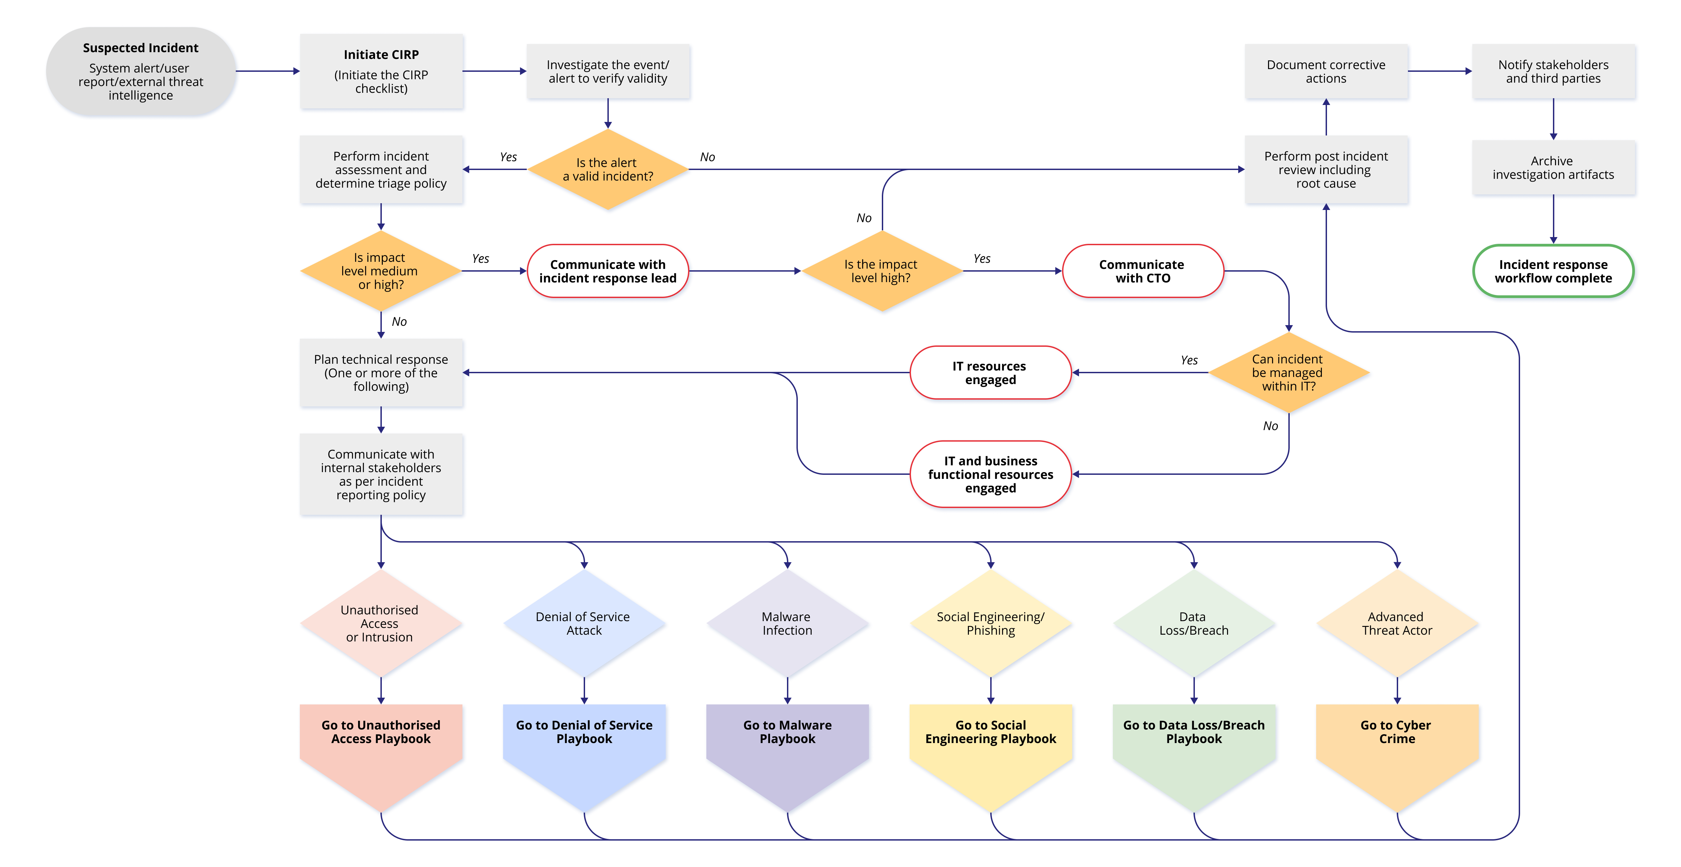Appendix D. {XXXX}’s Incident Response Playbooks

Appendix E. Incident Register
A sample incident register for information security incidents is provided below. An Incident Register can be maintained in any format, such as an Intranet webpage, Spreadsheets, or even in Word file format. Below are the minimum required fields for an incident register.
Incident Response Register
Num | Inc # | Date Opened | Date  Discovered | Date  Occurred | Date  Closed | Incident Response Point of Contact | Incident  Description | Asset Details | Follow-up/  Corrective Action Taken | Notification Reported to | Lessons  Learned
1
2
3

Appendix E. Incident Reporting Form
Incident Reporting Form
Incident Title:
Incident Ref #:
Incident Detector’s Information
Name:
Title:
Phone:
E-mail:
Address and Dept:
Incident Summary
Date and Time:
Incident Status:
Steps Taken:
Type of Incident (check all that apply):
☐ Phishing  ☐ Hacking attempt  ☐ Loss of confidential information |  | ☐ Insider threat  ☐ Social Engineering (Phone, email)  ☐ Other (Specify)  __________________________________
Affected System Information (Optional):
Site Location and Point of Contact:
Phone:
Affected System IP and Hostname:
Operating System:
How Many Host(s) Affected: | ☐ 1 to 10  ☐ 10 to 100  ☐ More than 100
Other Information:

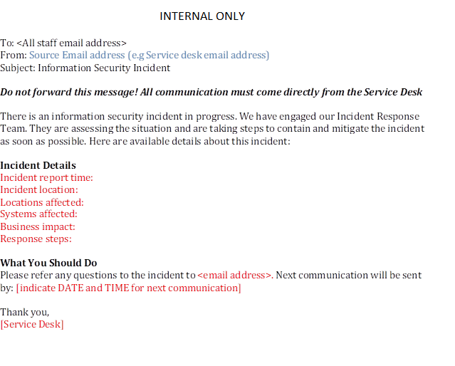
Appendix F. Communication Template – Internal Employees

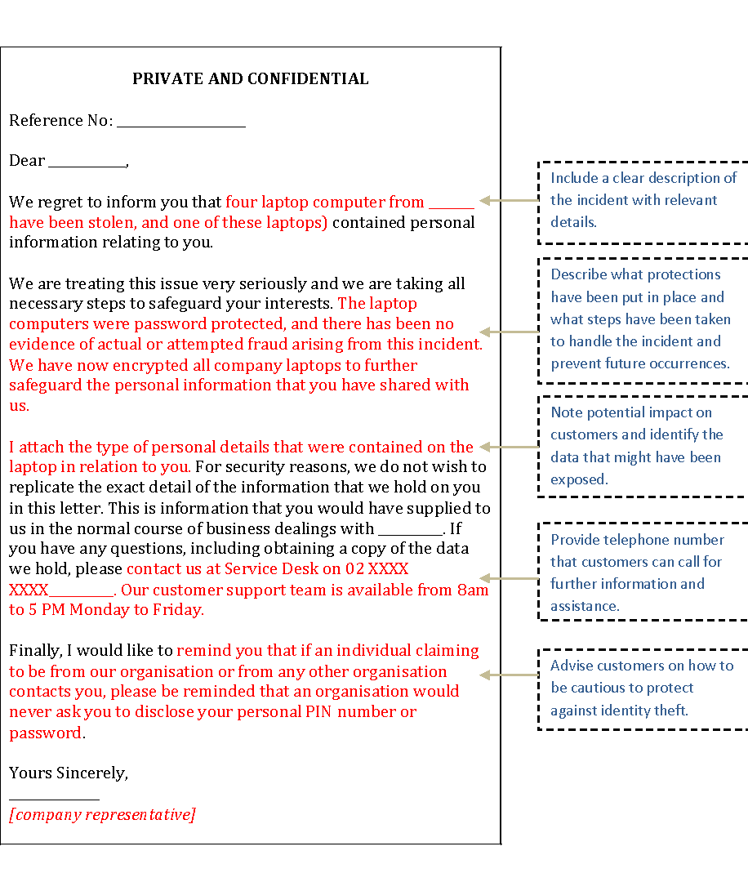
Appendix G. Communication Template – Customers

Appendix H. Contacting ACSC
The ITR is to report data spills or suspected cyber crime to the ACSC as soon as possible via:
https://www.cyber.gov.au/report
1300 CYBER1 (1300 292 371)
If there is any risk of immediate harm or loss of life, call 000 IMMEDIATELY.
After you report:
- Your report will be referred to the appropriate police jurisdiction for assessment.
- The Australian Cyber Security Centre (ACSC) will be unable to advise on the progress of a report as it will be referred directly to police for assessment.
Please note:
- Not all matters will be investigated by law enforcement. However, your report helps disrupt cyber crime operations and makes Australia the most secure place to connect online.
- You will not receive an email with a receipt of your report due to privacy and security reasons. We recommend that you download and safely store a copy of your report at completion.
- Some cyber crime may constitute an offence under the commonwealth and/or state and territory legislation.

Appendix I. Incident Response Contact List
Name | IRT Position | {XXXX} Position | Primary Mobile | Email Address
Internal
TBD
Organisation 1
Organisation 2

ISO27001 Annex A.16.1.2
ISM 0125
ISO A.6.1.3
ISM 0133
ISM 0138
ISM 0917
ISM 1091
ISM 1590
ISM 0123
ISM 0138

